Key Issue 3: Why Do Boundaries Cause Problems?
Pages 276-285

- Define boundary:

- Define physical boundary:

- Define cultural boundary:

- Complete the chart below to describe the advantages of each type of physical boundary.

Deserts | Mountains | Water

- What are three types of cultural boundaries that have often been used? Give an example of each type of cultural boundary and describe.

Case Study: Cyprus
- Bullet in the most significant facts regarding the boundary and ethnic situation in Cyprus. Annotate the map as appropriate.

Shapes of States
- Complete the chart based on your reading. The text gives examples of African countries that you should provide (map pg. 280).

Shapes |  | Examples
Compact | Greatest advantage…
Elongated | Biggest problem…
Prorupted | Reason for prorupting the shape of a state…
Perforated | How is the perforator state dependent on the “perforatee”?
Fragmented | Different kinds…

- Define landlocked state:

- Where are most of the world’s landlocked states?

- Why there?

- What problems do landlocked states have?

- Shade and label all 15 of Africa’s landlocked states. (Use Figure 8-33 to help)

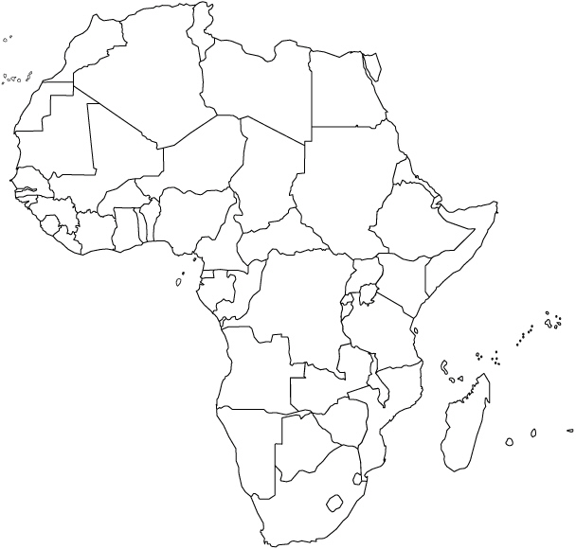

- Define democracy:
- Define autocracy:

- What are the three areas democracies and autocracies differ?

- Why has the world become more democratic?

- Explain the Arab Spring.

- Define unitary state:

- Define federal state:

- Regarding unitary states, what are the three characteristics that tend to favor it for a country?

- Where are unitary states most common?

- Multinational states often adopt unitary systems for what reason? Also, describe an example where this has occurred.

- Why is the federal state system more effective for larger states?

- List good examples of federal states that fulfill these conditions rather well.

- Why has tiny Belgium adopted a federal system?

- Why has enormous China adopted a unitary system?

- Describe the internal political organization of France in the box below.

France: Internal Political Organization
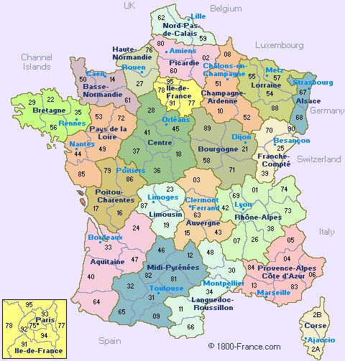

- Why are boundaries of legislative districts occasionally redrawn? How often is this done in the U.S.?

- How is this type of boundary redrawing different in the U.S. than in Europe?

- What is gerrymandering?

- What are the three types of gerrymandering? Explain them.

- How is gerrymandering combined with ethnicity for political use?

