Key Issue 4: Why do People Preserve Local Languages?
Pages 164-177
- Prepare detailed notes with bullets and notations on the maps regarding the following case studies:
- Belgium: Political & linguistic divides (Figure 5-27)
Switzerland: Peace in a multi-lingual state (Figure 5-29)
Nigeria: Problems in a multi-lingual state (Figure 5-30)

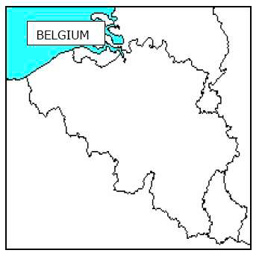
Notes:

Notes:

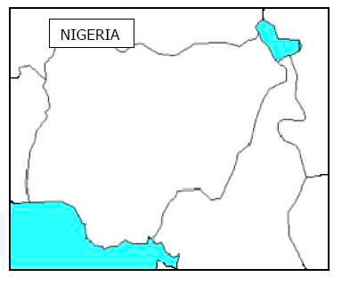
Notes:

- Complete the chart below by taking notes on the various languages/countries & the issues they are facing.
Basque –

Icelandic –

Native American –

Hebrew –

Celtic- (Welsh, Irish, Breton, Scottish, Cornish)

Australia-

New Zealand-

Occitan-

- Define lingua franca:

- Define pidgin language:

- How has expansion diffusion occurred with English? Give three examples.

- Does the United States have an official language? Why or why not?

- Discuss how the French language is important in Canada.

- Why is much of the internet in English? Why might this be problematic?

