Key Issue 1: Where Did Agriculture Originate?
Pages 346-351

***Always keep your key term packet out whenever you take notes from Rubenstein. As the terms come up in the text, think through the significance of the term.
- Define agriculture:

- Define crop:

- What are the characteristics of a hunter-gatherer society?

- How many hunter-gatherers are there today?

- Where do they live?

- What was the agricultural revolution?

- Using Figures 10-3 and 10-4, indicate the crop hearths and animal hearths on the map below.

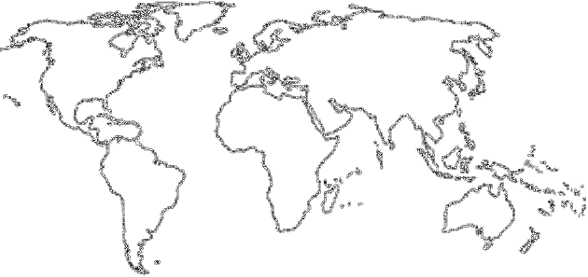

- Define subsistence agriculture:

- Define commercial agriculture:

- What are the three main features that separate commercial agriculture from subsistence agriculture?

- Read pgs. 350-351 and complete the chart below with important information. The text will generally explain commercial agriculture, and you will need to deduce the situation of subsistence agriculture on your own.
 | Subsistence Agriculture  (Mostly in LDCs) | Commercial Agriculture  (Mostly in MDCs)
% of Farmers in Labor Force
Use of Machinery
Farm Size

